Final Project
Golf Statistics Impact on Global Ranking
Kyle O’Keefe, Brendan Harman
December 4, 2025

Goals and Summary:
The primary objective of this project was to determine which specific performance statistics, such as driving distance, putting efficiency, or scoring average, are the strongest predictors of a professional golfer’s end of season world ranking. To do so, we performed a Spearman Rank Correlation analysis to isolate key success factors. Our results revealed that Scoring Average, unsurprisingly, is the strongest predictor of world ranking, serving as the baseline for success. However, the more revealing insight came from analyzing specific technical skills. Greens in Regulation (GIR) and Driving Distance (DDIS) were the only technical metrics that showed a statistically significant correlation with high rankings. In contrast, Driving Accuracy showed almost no correlation, suggesting that modern professional golf has evolved to favor more powerful golfers, where maximizing distance and ball-striking affords greater advantages than strictly prioritizing hitting fairways.
Context:
The data investigated came from two sources. One being the Official World Golf Ranking, in which only End, Average Points, and Total Points were used in the analysis. These metrics are based on the company’s own formula that grants players points based on their outcome in different tournaments. Higher stakes tournaments intuitively are more impactful and have more available points than low level events, also, team events are not eligible for points. The End metric represents a player ranking at the end of the 2024 season based on how many points they have.
The 2024 season matches the timeline of our other dataset used, which is player statistics from ESPN for the 2024 season. In this dataset we used a variety of statistical metrics. The metrics are explained as follows.
Name | A player’s name
Age | A players age
Cup | Number of FedEx Cup Points (a separate measure of points similar to world ranking however these points are only given for PGA Tour events whereas world ranking represents 24 different tours)
Evnts | Number of events played
Rnds | Number of rounds played (there are typically 4 rounds over 4 days in one event where all players participate in the first two and only the players who make the cut advance to the final two)
Cuts | Number of cuts made (a cut happens after the first two rounds of a event where only the top players advance, this number can change but is typically in the top 50-70 range)
Top10 | Number of times a player finished top 10 in an event
Wins | Number of times a player won an event
Score | Average score for one round
DDIS | Average driving distance
DACC | Average driving accuracy (a ratio of how many times a drive hits a fairway)
GIR | Greens in regulation (a ratio of how many times you hit a green in regulation. This is achieved when your ball is on the green in two shots less than par so, if there is a par 4 and the second shot lands on the green then it would be a green in regulation)
Putts | Average number of putts per hole
Sand | Sand saves (a ratio of successful saves. A successful save consists of going up and down from a greenside bunker which means hitting the ball from the bunker onto the green and only having one putt)
Birds | Average number of birdies in a round (a birdie is scoring one less than par on a hole, so a 3 would be a birdie on a par 4)

The data can be found at these links: https://www.owgr.com/current-world-ranking, https://www.espn.com/golf/stats/player/_/season/2024/table/general/sort/cupPoints/dir/desc. To get the data to a point that it was useful, it first necessary to adjust some of the players’ names to match, remove unnecessary columns and merge the data once clean. It is also important to note that the statistical data only comes from PGA Tour Players which may present some bias in the findings since the world ranking includes many other tours.

Testing:
To quantitatively assess the relationship between a player’s statistics and their ranking, we utilized the Spearman Rank Correlation test. We chose a correlation analysis because our primary goal was to measure the strength and direction of the association between specific performance metrics and a player's final ranking. This allows us to move beyond simple observation and statistically quantify which skills are most tightly linked to competitive success.
Spearman's Rho is a statistical measure that tells us how strongly two variables are correlated on a scale from -1 to +1. The closer the number is to either end of the scale (-1 or +1), the stronger the connection between the skill and the ranking. A value near 0 means there is no consistent relationship. To interpret our results correctly, it is important to note that a lower ranking number is better (rank #1 is the best). Therefore, a negative correlation is actually a positive finding for a skill, it means that as the skill statistic increases (e.g., longer drives), the player's rank number goes down (improves). Conversely, a positive correlation means that as the statistic increases (e.g., higher score), the rank number goes up (worsens). The P-Value indicates the probability that these results occurred by random chance, so lower P-Values mean more significance. A P-Value below 0.05 confirms that the relationship is statistically significant.

We focused our testing on the technical statistics that we hypothesized would have the most significance. The analysis produced the following results:
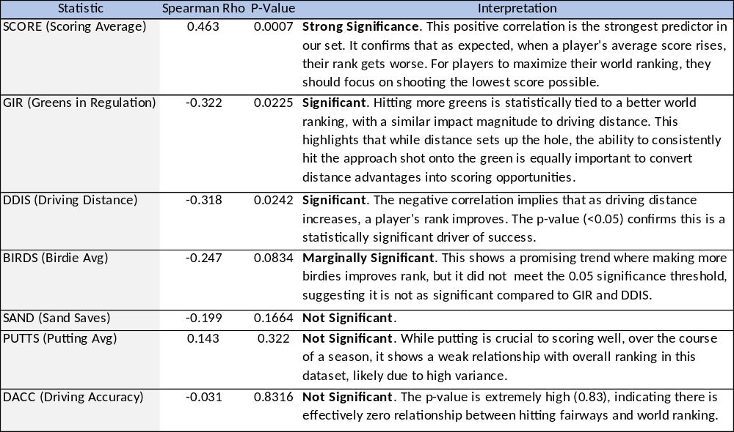
Conclusion:
In the world of analytics driven golf, these findings prove to be important in a variety of ways and can already be seen in how players approach the game. With driving distance having more statistical significance on world ranking than accuracy, it makes sense that most of the top golfers are hitting it further and worrying less about where they are hitting it off the tee. Also, it makes sense that one of the world’s best when it comes to greens in regulation is ranked number 1, Scottie Scheffler. Backing up the findings that consistently hitting greens in regulation is significant on a player ranking.
The last statistic to mention is the most statistically significant. That statistic is a player’s average score. This makes sense because the better a player scores, the higher they finish in a tournament, meaning they will get more points and be ranked higher. And although this is the most statistically significant metric, it may not be as important to individual players as there is no one way to improve a score like there is for the other metrics. Of course, it is still the whole goal for a player to get a low score, however when improving their game, a player might cater their practice in one area at a time like greens in regulation or driving distance which will in turn improve their score overall.
A limitation in the overall analysis of the data, mentioned earlier, is that one data source is from PGA Tour events and another includes all events. A more rigorous test that could further the findings might have statistics from every event used in the Official World Golf Ranking. Also, the statistics only include the top 50 players from PGA Tour events so expanding the set to include more players might also be interesting to investigate. Despite these limitations however, the analysis of the data still proves to be impactful to investigate.

